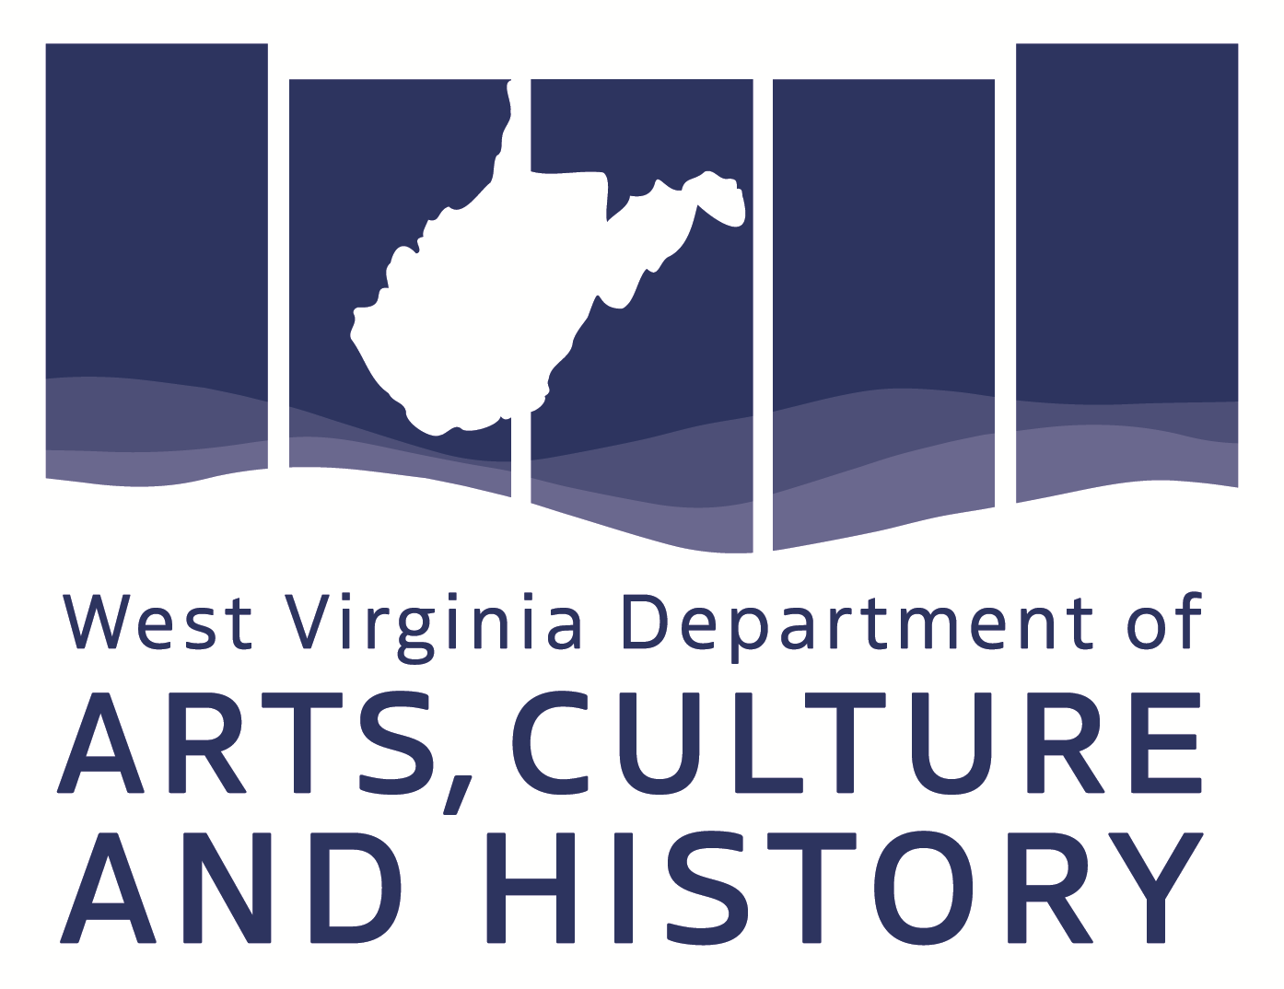
FY2022 Rural Youth
Engagement through
Public Art Grant

DEADLINE:
October 1, 2021

GRANT PERIOD:
January 1, 2022 – June 30, 2022

CONTENTS:
Instructions, application, and scoring rubric

PROGRAM CONTACT:
Jenna Green, Cultural Facilities and Capital Resources Coordinator
Jenna.R.Green@wv.gov

This is a program of the WV Department of Arts, Culture and History in association with the West Virginia Commission on the Arts.
The Culture Center / 1900 Kanawha Boulevard, East / Charleston, WV 25305-0300

P: 304-558-0240 / TDD: 304-558-3562 / F: 304-558-3560 www.wvculture.org
All publications and application forms are available in alternative formats upon request.
Jenna Green ADA Coordinator, jenna.r.green@wv.gov 304-558-0240 or 304-558-3562 (TDD)

APPLICATION INSTRUCTIONS:
What is the purpose of this grant program?
- To provide up to $5,000 in support for visual two- and three-dimensional public art projects in rural areas that engage local youth in the planning and/or implementation of the project.
- Projects must take place in West Virginia communities.
- Projects may be indoors or outdoors but must in a public place and experienced free of charge.

Who may apply to this program?
- Schools
- 501(c)(3) WV youth or arts organizations
- Local governments

What are eligible expenses?
- Artist fees
- Materials
- Equipment purchases or rentals
- Engineering/consulting fees

Does this grant require matching funds?
- Yes. Applicants must provide a 25% match to the total project costs.

How will our application be evaluated?
- A panel consisting of West Virginia Commission on the Arts members and staff will review applications. Funds will be awarded based on available funding, quality of the proposed project, and potential impact on the community.
- A scoring rubric is attached to this application.
- Bonus points will be given to projects that take place in counties designated as at-risk or distressed by the Appalachian Regional Commission. View the county designations here: https://www.arc.gov/wp-content/uploads/2020/07/CountyEconomicStatusandDistressAreasFY2021WestVirginia.pdf.

How do I apply to this grant program?
- Complete the application and submit to the WVCA through email.
- Applications must be sent to Jenna.R.Green@wv.gov by 11:59 p.m. on Friday, October 1, 2021.

Submission Instructions
- Forms are compatible with Microsoft Word.
- Form fields are highlighted in gray; fields will automatically expand.
- Spell Check is not active within the application, so proofread outside of the document.
- Handwritten applications will not be considered.
- Sign the application and submit one digital file containing the application and attachments.

Are there reporting requirements for this grant?
- Yes. Grant recipients must file a final report 30 days after the conclusion of the project, or by July 30, 2022.

SUBMISSION CHECKLIST:
Use the Submission Checklist to finalize your package; the checklist represents an entire application package and the order in which the materials should be packaged.

ALL ITEMS ARE REQUIRED
PART I Applicant Cover Page
PART II Certification Statement
PART III Narrative
PART IV Expenses
PART V Statement of Compliance-Americans with Disabilities Act
Attachment(s): Documentation of Expenses – All project expenses must be documented in this application.
Examples of documentation:
  - Contracts with artists
  - Quotes from vendors
  - Images of products (with price) from vendor websites
  - Estimates from rental companies
  - Conceptual designs of proposed project

Submit your completed package to:
Jenna Green, Cultural Facilities and Capital Resources Coordinator
Jenna.R.Green@wv.gov

First time applicants are strongly encouraged to submit a draft of
application to arts staff for review prior to the October 1 deadline.
FY2021 Rural Youth Engagement through Public Art Grant
Do not write in this space
Date received: ______________________
Application #: ______________________
PRN: _____________________________

PART I: APPLICANT COVER PAGE
COMPLETE ALL FIELDS

Applicant’s Legal Name:
Applicant’s Mailing Address:
City: State:
Zip: County:
Website:

Individual to be contacted with questions about the application. The WVCA/Arts staff will only share information regarding your grant with the Contact Person and signer of the grant.
Name and Title of Contact Person:
Phone daytime / Phone non-bus hours:
E-mail:

Federal Employer Identification Number or FEIN:

Data Universal Numbering System or D-U-N-S® Number:
*You may request a D-U-N-S Number at http://fedgov.dnb.com/webform/pages/CCRSearch.jspation

Code your organization status in the following categories using the attached National Standard Coding Sheet:
Applicant status: Applicant institution: Discipline (number and letter):

Code your project in the following categories using the attached National Standard Coding Sheet:
Type of Activity: Populations benefitted by Distinct Group:
Arts Education: Populations benefitted by Age:
Project Discipline: Populations benefitted by Race/Ethnicity:

NEA Primary Strategic Outcome:
Choose the one that best describes the PRIMARY strategic outcome associated with this project award.
A. Creation: The Portfolio of American Art is Expanded
B. Engagement: Americans Throughout the Nation Experience Art
C. Learning: Americans of All Ages Acquire Knowledge or Skills in the Arts
D. Livability: American Communities Are Strengthened Through the Arts
E. Understanding: Public Knowledge and Understanding about the Contributions of the Arts Are Enhanced

Complete this sentence: The grant funds will be used to:
PART II: CERTIFICATION STATEMENT
READ, SIGN, AND DATE
The person signing the application must have legal authority to obligate the organization and cannot be a recipient of grant funds.

I certify that:
1) The information in this application is true and correct to the best of my ability.
2) The organization’s Board of Directors has approved this project.
3) I have the legal authority to obligate the applicant.

Profits made from any project receiving support from the West Virginia Commission on the Arts (WVCA) will be used in support of the arts or artists. I have read and understood the guidelines and will comply with all rules, regulations, laws, terms, and conditions described therein. I agree to allow the WVCA to duplicate any materials submitted with this application for the purposes of selection process, education, and reports to the National Endowment for the Arts.

Name:
Title:

Signature: _________________________________________________ DATE: ______________

Email Address:

PART III: NARRATIVE
LIMIT RESPONSES TO 1 PAGE PER QUESTION

- Briefly describe your organization’s history, mission, and goals.

- Provide a description of your project. Explain the who, what, when, where, why, and how.

- Describe how local youth will be involved in this project.

- Describe the benefits this project will have on the local community.

- What health and safety policies will be in place during the creation and implementation of your project?

PART IV: EXPENSES (Grant Period: January 1, 2022 – June 30, 2022)
- Provide documentation of all expenses as attachments to this application. Documentation may include, but is not limited to:
  - Contracts with artists
  - Quotes from vendors
  - Images of products (with price) from vendor websites
  - Estimates from rental companies
  - Conceptual designs of proposed project
- Organizations can request 75% of the total project expenses, up to $5,000
- List all project expenses in addition to the grant amount requested for this project.

EXPENSES | COST
Artist fees | $
Materials | $
Fabrication | $
Equipment purchases and/or rentals | $
Engineering or consulting fees | $
Other (please explain below) | $
Other (please explain below) | $
Other (please explain below) | $
Total Project Expenses $
Grant Request (75% of total project expenses, up to $5,000) $

Please describe any expenses listed in “Other.”

How will your organization raise the matching funds for this project?

PART V: STATEMENT OF COMPLIANCE - AMERICANS WITH DISABILITIES ACT
GRANT APPLICANT MUST READ, SIGN AND DATE

Applicant/Organization Name:
Physical Address of Applicant Facility:

If different from Applicant Facility above, list all location(s) in which the project will take place.

The West Virginia Commission on the Arts asks applicants to describe efforts to improve programmatic and physical access in its organization as a means to evaluate the degree to which it is proactively working on these issues. The WVCA is not in the position to determine whether an applicant is in compliance with any state and federal laws governing this subject. A WVCA grant should not be interpreted as an opinion on that organization’s compliance with its legal obligations. Each organization is responsible for complying with all applicable laws, rules, and regulations. All organizations that are not in full compliance must complete the Transition Plan available at: http://www.wvculture.org/arts/grants/ADA/ADATransitionPlan.pdf.
Contact Jenna Green, Accessibility Coordinator at (304) 558-0240 ext. 725 with any questions.
APPLICANT PROJECT ONLY TAKES PLACE AT APPLICANT FACILITY LISTED ABOVE AND APPLICANT FACILITY AND PROGRAMMING ARE IN FULL COMPLIANCE WITH THE AMERICANS WITH DISABILITIES ACT. Applicants who are in full compliance do not need to complete and attach the Transition Plan.
APPLICANT PROJECT TAKES PLACE AT APPLICANT FACILITY AND OTHER LOCATIONS LISTED ABOVE; ALL PROJECT FACILITIES AND PRESENTED PROGRAMS IN ASSOCIATION WITH PROJECT ARE IN FULL COMPLIANCE WITH THE AMERICANS WITH DISABILITIES ACT. Applicant acknowledges that ADA applies to each location in which the project is held. Applicants whose project takes place within another location, even schools, is an equal partner in providing ADA compliance.

APPLICANT PROJECT AND/OR FACILITY IN WHICH PROJECT TAKES PLACE IS NOT IN FULL COMPLIANCE WITH THE AMERICANS WITH DISABILITIES ACT (ADA) AND WE HAVE COMPLETED AND ATTACHED THE TRANSITION PLAN.

OFFICIAL WITH AUTHORITY TO CONTRACT FOR THE APPLICANT
Name:
Title:
Phone:

Signature: ______________________________________________ Date: ___________

NATIONAL STANDARD CODING SHEET
APPLICANT STATUS 18 Union/Professional Association D. Industrial
01 Individual 19 School District E. Interior
02 Organization – Nonprofit 20 Parent-Teacher Organization F. Landscape Architecture
03 Organization – Profit 21 Elementary School G. Urban/Metropolitan
04 Government – Federal 22 Middle School 07 Crafts
05 Government – State 23 Secondary School A. Clay
06 Government – Regional 24 Vocational/Technical School B. Fiber
07 Government – County 25 Other School C. Glass
08 Government – Municipal 26 College/University D. Leather
09 Government – Tribal 27 Library E. Metal
99 None of the above 28 Historical Society F. Paper
TYPE OF ACTIVITY 29 Humanities Council G. Plastic
01 Acquisition 30 Foundation H. Wood
02 Audience Services 31 Corporation I. Mixed Media
03 Fellowships 32 Community Service Organization 08 Photography
04 Artwork Creation 33 Correctional Institution A. Media Arts
05 Concert/Performance/Reading 34 Health Care Facility B. Film
06 Exhibition 35 Religious Organization C. Audio
07 Facility Construction/Maintenance 36 Senior Center D. Video
08 Fair/Festival 37 Parks and Recreation E. Technology/Experimental
09 Identification/Documentation 38 Government – Executive 09 Media Arts
10 Organization Establishment 39 Government – Judicial A. Film
11 Operating Support 40 Government – (House) B. Audio
12 Arts Instruction 41 Government – (Senate) C. Video
13 Marketing 42 Media – Periodical D. Technology/Experimental
14 Professional Support – Admin. 43 Media – Daily Newspaper 10. Literature
15 Professional Support – Artistic 44 Media – Weekly Newspaper A. Fiction
16 Recording/Filming/Taping 45 Media – Radio ` B. Nonfiction
17 Publication 46 Media – TV C. Playwriting
18 Repair/Restoration/Conservation 47 Cultural Series Organization D. Poetry
19 Research/Planning 48 School of the Arts 11. Interdisciplinary
20 School Residency 49 Arts Camp/Institute 12. Folk Life/Traditional Arts
21 Other Residency 50 Social Service Organization A. Folk/Traditional Dance
22 Seminar/Conference 51 Child Care Provider B. Folk/Traditional Music
23 Equipment Acquisition 99 None of the Above C. Folk/Traditional Crafts & Visual Arts
24 Distribution of Art DISCIPLINES (Applicant & Project) D. Oral Traditions/Storytelling
25 Apprenticeship 01 Dance 13. Humanities
26 Re-granting A. Ballet 14. Multidisciplinary
27 Translation B. Ethnic/Jazz 15. Non-Arts/Non-Humanities
28 Writing about Art C. Modern NEA PRIMARY STRATEGIC OUTCOME
29 Professional Development/Training 02 Music A. Creation
30 Student Assessment A. Band B. Engagement
31 Curriculum Development/Implementation B. Chamber C. Learning
32 Stabilization/Endowment/Challenge C. Choral D. Livability
33 Building Public Awareness D. New E. Understanding
34 Technical Assistance E. Ethnic ARTS EDUCATION
35 Website/Internet Development F. Jazz 01 50% or more of funded activities are arts education
36 Broadcasting G. Popular 02 Less than 50% of funded activities are arts education
37 Public Art/Percent for Art H. Solo/Recital 99 No arts in education involved in project
99 None of the Above I. Orchestral POPULATIONS BENEFITTED BY RACE
APPLICANT INSTITUTION 03 Opera/Musical Theater A. Asian
01 Individual Artist A. Opera B. African American
02 Individual Non-Artist B. Musical Theater C. Hispanic/Latino
03 Performing Group 04 Theater D. American Indian/Alaska Native
04 Performing Group - College/University A. General E. Native Hawaiian/Pacific Islander
05 Performing Group – Community B. Mime F. White
06 Performing Group – Youth C. Puppet G. No single race made up more than 25%
07 Performance Facility D. For Young Audiences POPULATIONS BENEFITTED BY AGE
08 Art Museum E. Storytelling 01 Children 0-18 years
09 Other Museum 05 Visual Arts 02 Young Adults 19-24 years
10 Gallery/Exhibit Space A. Experimental 03 Adult 65+ years
11 Cinema B. Graphics 99 None of the above
12 Independent Press C. Painting POPULATIONS BENEFITTED BY DISTINCT GROUPS
13 Literary Magazine D. Sculpture D Individuals with Disabilities
14 Fair/Festival 06 Design Arts I Individuals in Institutions
15 Arts Center A. Architecture P Individuals below the poverty line
16 Arts Council/Agency B. Fashion E Individuals with limited English proficiency
17 Arts Service Organization C. Graphic M Military veterans/Active duty personnel
Y Youth at risk
G None of the above

Criteria and Comments | Points Possible | Score
Quality of proposed project  Does the application describe a project that is well thought out and likely to be successful? Is the budget realistic? | 0-25
Youth engagement  Does the application demonstrate a clear plan for engaging local youth? Are young people involved at most or all stages of the project? | 0-25
Potential impact  Is this project likely to benefit the community where it is located? Will West Virginia artists be hired? Will West Virginia vendors be used for material purchases or equipment rentals? | 0-25
Overall presentation of application  Does the application provide clear, complete information with enough detail to understand the full scope of the project? Has the applicant included sufficient documentation to support the request? Is the application free of misspellings and grammatical errors? | 0-25
Points Possible: | 100
BONUS: Preference given to projects that:
Are in counties designated as at-risk or distressed by the Appalachian Regional Commission | 5
Total Score:
Rural Youth Engagement through Public Art – Scoring Rubric

Applicant: _______________________ Grant #: ________________ Reviewer: ________________________

