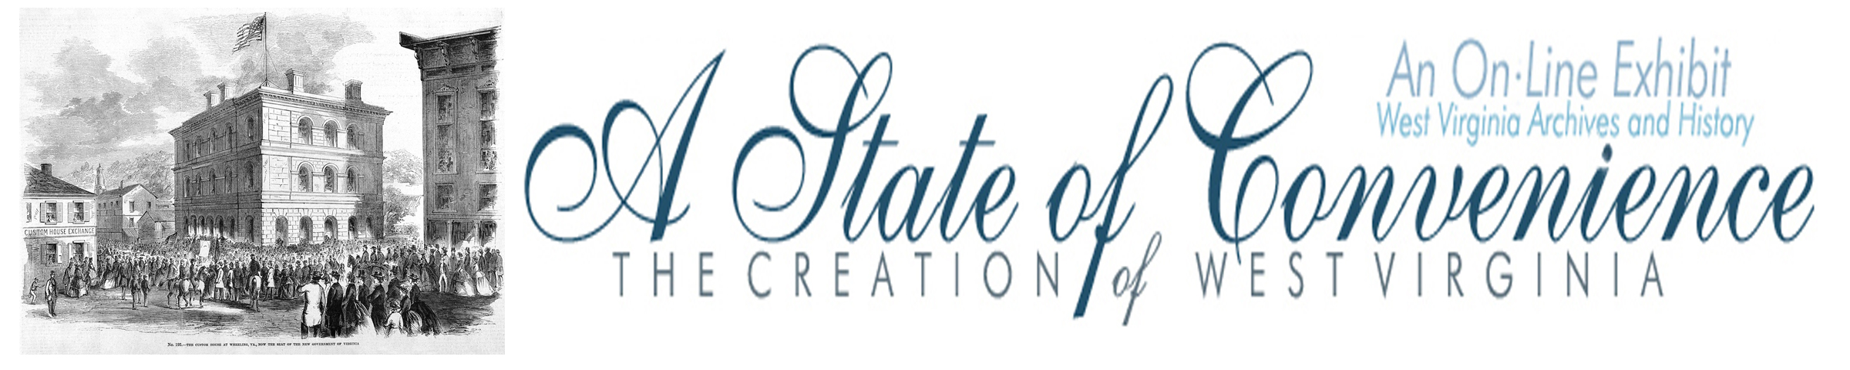

Name ______________________________ Date _______________ Period ________

Directions: Navigate to http://www.wvculture.org/history/statehood/statehoodtoc.html on the internet. Read the Introduction and go to the Table of Contents. Go to Chapter 1: East vs. West and answer the following questions.

East vs. West

1. The image from Howe’s History of Virginia shows two views of Virginia. Describe the differences between these two views in the boxes below.

East | West

2. Who was given voting rights according the Virginia State Constitution adopted in 1776? Who benefited from this provision?

3. When John G. Jackson penned his letter under the pseudonym “A Mountaineer,” how many representatives for the General Assembly came from each county and how many counties were found west of the Blue Ridge Mountains? Why was Jackson upset about this?

4. What were the three main concessions made by Easterners following conventions held in Staunton in 1816 and 1825?

5. What changes did western Virginians want during the Constitutional Convention of 1829-1830? What was the result and how did some westerners respond?

6. What were the results of the Virginia Constitutional Convention (also known as the Reform Convention) in 1850-1851?

7. By the late 1850s what was the relationship between easterners and westerners in Virginia?

8. What impact did John Brown’s Raid at Harpers Ferry have on the relationship between eastern and western Virginia?

Answer Key
East vs. West Worksheet

1. The image from Howe’s History of Virginia shows the two views of Virginia. What are the differences between these two views?

The Eastern view is of a plantation with slaves, while the Western view is of a mountaineer with a small cabin in the mountains.

2. Who was given voting rights according the Virginia State Constitution adopted in 1776? Who benefited from this provision?

The 1776 Virginia State Constitution granted voting rights only to white males owning at least 25 acres of improved or 50 acres of unimproved land. The provision benefited plantation owners in Eastern Virginia.

3. When John G. Jackson penned his letter under the pseudonym “A Mountaineer,” how many representatives for the General Assembly came from each county and how many counties were found west of the Blue Ridge Mountains? Why was Jackson upset about this?

Each county was represented by two delegates no matter what the population was. The west was made up of 4 of the states 24 counties. Jackson was upset because many men in the west were unable to vote and they were underrepresented in the General Assembly.

4. What were the three main concessions made by Easterners following conventions held in Staunton in 1816 and 1825?

1. Reapportionment of the Senate based on white population instead of total population including slaves.
2. The Board of Public Works was created to legislate internal improvements like roads and canals.
3. The establishment of state banks in Winchester and Wheeling.

5. What changes did western Virginians want during the Constitutional Convention of 1829-1830? What was the result and how did some westerners respond?

Westerners during the Constitutional Convention of 1829-1830 had hoped to achieve universal white male suffrage and the direct election of state and local officials. The efforts failed and several newspapers in the west called for secession from Virginia.

6. What were the results of the Virginia Constitutional Convention (also known as the Reform Convention) in 1850-1851?

Easterners and westerners agreed to: universal white male suffrage for men over the age of 21; the direct election of governor and judges by the people; and a provision to tax property at its total value, except slaves who were valued at rates below their actual worth.

7. By the late 1850s what was the relationship between easterners and westerners in Virginia?

They were closer politically than they had ever been.

8. What impact did John Brown’s Raid at Harpers Ferry have on the relationship between eastern and western Virginia?

John Brown’s Raid added more tension to the trouble relationship between eastern and western
Virginians .

