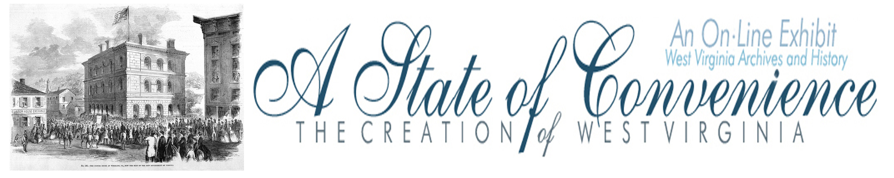

Name ______________________________________ Date _______________ Period ________

The Election of 1860

Directions: Go to http://www.wvculture.org/history/statehood/statehood02.html, read the chapter on The Election of 1860 and answer the questions below.

1. Complete the following chart concerning the 1860 presidential candidates.

U.S. Presidential Candidates 1860
Party | President | Vice President
Republican Party

Democratic Party – North

Democratic Party – South

Constitutional Union Party

2. Who received the most votes in Virginia?

3. Who received the second most votes in Virginia?

4. What region of Virginia provided Lincoln with the majority of his votes?

5. Who won the presidency and what happened following his election?

Answer Key
The Election of 1860

1. Complete the following chart concerning the 1860 presidential candidates.

U.S. Presidential Candidates 1860
Party | President | Vice President
Republican Party | Abraham Lincoln | Hannibal Hamlin
Democratic Party – North | Stephen Douglas | Herschel V. Johnson
Democratic Party – South | John Breckinridge | Joseph Lane
Constitutional Union Party | John Bell | Edward Everett

2. Who received the most votes in Virginia?

John Bell

3. Who received the second most votes in Virginia?

John Breckinridge

4. What region of Virginia provided Lincoln with the majority of his votes?

Northwestern

5. Who won the presidency and what happened following his election?

Abraham Lincoln. Southern states began withdrawing from the Union.

