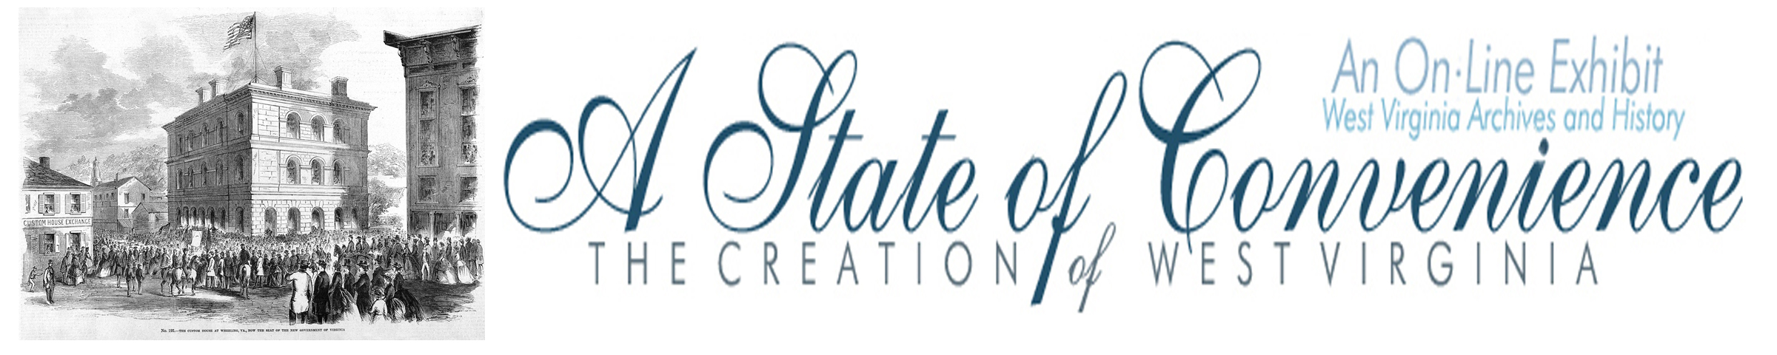

Name ______________________________________ Date _______________ Period ________

The Virginia Ordinance of Secession

Directions: Go to http://www.wvculture.org/history/statehood/ordinanceofsecession.html and answer the following questions.

1. What did the Virginia Ordinance of Secession attempt to repeal?

2. What were the reasons given for the creation of the Ordinance of Secession?

3. What was Virginia claiming by dissolving the Union?

4. What was the method for approving the ordinance?

5. When was the ordinance to go into effect?

Answer Key
The Virginia Ordinance of Secession

1. What did the Virginia Ordinance of Secession attempt to repeal?

The ordinance attempted to repeal Virginia’s ratification of the U.S. Constitution.

2. What were the reasons given for the creation of the Ordinance of Secession?

The ordinance claimed that the U.S. government caused injury to the people of Virginia and oppressed
southern slaveholding states.

3. What was Virginia claiming by dissolving the Union?

Virginia was claiming that they were a free and independent state.

4. What was the method for approving the ordinance?

A state referendum or vote of the citizens of Virginia was the method chosen to ratify the secession
ordinance.

5. When was the ordinance to go into effect?

The secession ordinance was set to going to effect following the statewide vote on the fourth Thursday of May 1861 (May 23, 1861).

