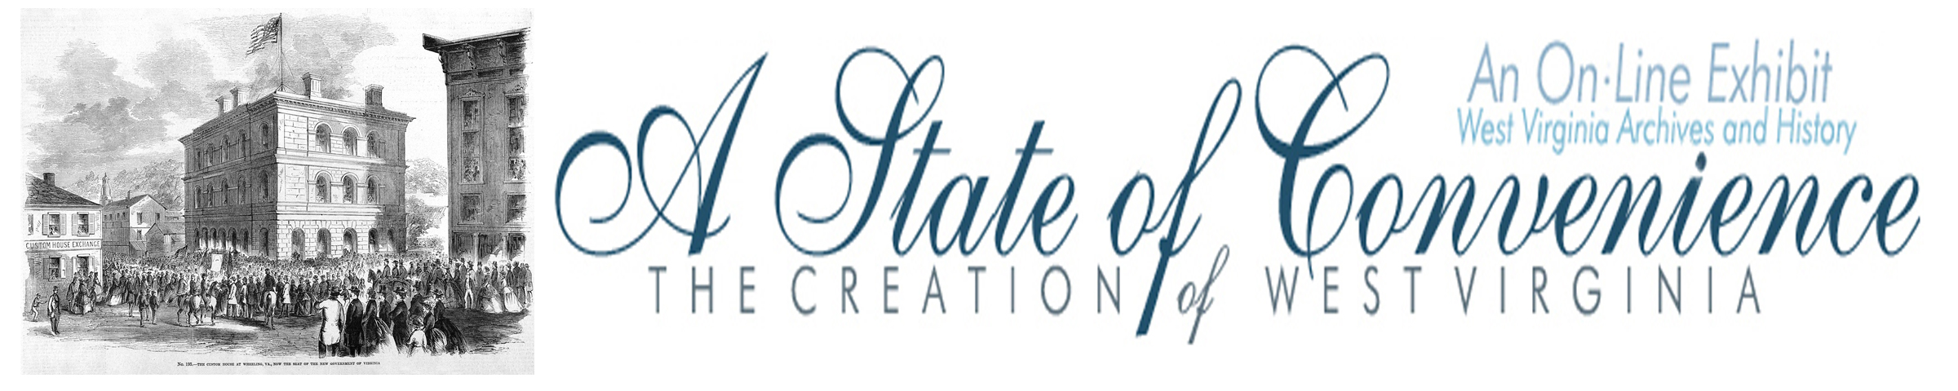

Name ______________________________________ Date _______________ Period ________

The Clarksburg Convention

Directions: Go to http://www.wvculture.org/history/statehood/statehood04.html and http://www.wvculture.org/history/statehood/clarksburgconvention.html and answer the following questions.

1. When was the Clarksburg Convention held?

2. What was the purpose of the convention?

View Resolutions Approved at the Clarksburg Convention at: http://www.wvculture.org/history/statehood/clarksburgconvention.html

3. According to the preamble what did the Richmond Convention do “contrary to the expectation of a large majority of the people of this State?”

4. What did the Governor of the Commonwealth undertake by proclamation without the consent of the voters?

5. According to the preamble what is the “great conservator a free people’s liberties?”

6. How did Virginia display hostility to the federal government?

7. What did the governor inaugurate “without consulting those in whose name they profess to act?”

8. What did the convention urge counties of Northwestern Virginia to do?

9. What was the final outcome of the Clarksburg Convention?

Answer Key
The Clarksburg Convention

1. When was the Clarksburg Conventionheld?

April 22, 1861

2. What was the purpose of the convention?

The reason for the convention was for westerners to respond to the Ordinance of Secession.

View Resolutions Approved at the Clarksburg Convention at: http://www.wvculture.org/history/statehood/clarksburgconvention.html

3. According to the preamble what did the Richmond Convention do “contrary to the expectation of a large majority of the people of this State?”

The convention “adopted an ordinance withdrawing Virginia from the Federal Union.”

4. What did the Governor of the Commonwealth undertake by proclamation without the consent of the voters?

He called the volunteer soldiery of the state to report to him and hold themselves ready to make war on the federal government.

5. According to the preamble what is the “great conservator of a free people’s liberties?”

The ballot-box is the great conservator of a free people’s liberty.

6. How did Virginia display hostility to the federal government?

The state displayed hostility by seizing ships, taking control of Custom Houses, tearing down flags, and attacking the federal arsenal at Harpers Ferry and inaugurating war with out the vote of the people.

7. What did the governor inaugurate “without consulting those in whose name they profess to act?”

The governor inaugurated war by attacking the federal arsenal at Harpers Ferry before the passage of the secession ordinance.

8. What did the convention urge counties of Northwestern Virginia to do?

The convention urged the counties of western Virginia to send delegates to Wheeling on May 13 to determine the action of northwestern Virginia in the present emergency.

9. What was the final outcome of the Clarksburg Convention?

The Clarksburg Convention led to the First Wheeling Convention.

