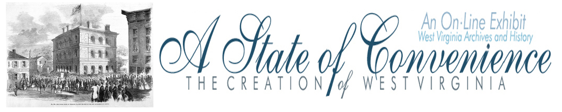

Name ______________________________________ Date _______________ Period ________

The Clarksburg Convention

Directions: Read the resolutions from the Clarksburg Convention from the Wheeling Intelligencer, April 25, 1861 and answer the following questions.

Clarksburg Convention
April 22, 1861
NORTHWESTERN VIRGINIA.
Great Movement in Harrison County for a Separate Organization
of the Northwest from the Seceders.
CONVENTION CALLED IN THIS CITY ON THE 13TH OF MAY.
From the Clarksburg Guard, Extra
At a large and enthusiastic meeting of from 1,000 to 1,200 of the citizens of Harrison county, assembled at the Court House upon a notice of forty-eight hours, on Monday, April 22, 1861, the following preamble and resolutions were adopted without one dissenting voice.
PREAMBLE.
WHEREAS, The Convention now in session in this State, called by the Legislature, the members of which had been elected twenty months before said call, at a time when no such action as the assemblage of a convention by legislative enactment was contemplated by the people, or expected by the members they elected in May, 1859, at which time no one anticipated the troubles recently brought upon our common country by the extraordinary action of the State authorities of South Carolina, Georgia, Alabama, Mississippi, Florida, Louisiana, and Texas, has, contrary to the expectation of a large majority of the people of this State, adopted an ordinance withdrawing Virginia from the Federal Union: and whereas, by the law calling said Convention, it is expressly declared that no such ordinance shall have force or effect, or be of binding obligation upon the people of this State, until the same shall be ratified by the voters at the polls,: and whereas, we have seen with regret that demonstrations of hostility, unauthorized by law, and inconsistent with the duty of law-abiding citizens, still owing allegiance to the Federal Government, have been made by a portion of the people of this State against the said Government: and whereas, the Governor of this Commonwealth, has, by proclamation, undertaken to decide for the people of Virginia, that which they have reserved to themselves, the right to decide by their votes at the polls, and has called upon the volunteer soldiery of this State to report to him and hold themselves in readiness to make war upon the Federal Government, which Government is Virginia's Government, and must in law and of right continue so to be, until the people of Virginia shall, by their votes, and through the ballot-box, that great conservator of a free people's liberties, decide otherwise: and whereas, the peculiar situation of Northwestern Virginia, separated as it is by natural barriers from the rest of the State, precludes all hope of timely succor in the hour of danger from other portions of the State, and demands that we should look to and provide for our own safety in the fearful emergency in which we now find ourselves placed by the action of our State authorities, who have disregarded the great fundamental principle upon which our beautiful system of Government is based, to wit: "That all governmental power is derived from the consent of the governed," and have without consulting the people placed this State in hostility to the Government by seizing upon its ships and obstructing the channel at the mouth of Elizabeth river, by wresting from the Federal officers at Norfolk and Richmond the custom houses, by tearing from the Nation's property the Nation's flag, and putting in its place a bunting, the emblem of rebellion, and by marching upon the National Armory at Harper's Ferry; thus inaugurating a war without consulting those in whose name they profess to act; and whereas, the exposed condition of Northwestern Virginia requires that her people should be united in action, and unanimous in purpose - there being a perfect identity of interests in times of war as well as in peace - therefore, be it
Resolved, That it be and is hereby recommended to the people in each and all of the counties composing Northwestern Virginia to appoint delegates, not less than five in number, of their wisest, best, and discreetest men, to meet in Convention at Wheeling, on the 13th day of May next, to consult and determine upon such action as the people of Northwestern Virginia should take in the present fearful emergency,
Resolved, That Hon: John S. Carlile, W. Goff, Hon. Chas. S. Lewis, J. Davis, Lot Bowen, Dr. Wm. Dunkin, W. E. Lyon, Felix Sturm, and James Lynch be and are hereby appointed delegates to represent this county in said Convention.
JOHN HURLEY, Pres.
J. W. Harris, Sec'y.
Strange to say, among that large assembly, not a single response was heard to the call by the President for the nays on any of the questions before the meeting.

Questions
1. According to the preamble what did the Richmond Convention do “contrary to the expectation of a large majority of the people of this State?”

2. What did the Governor of the Commonwealth undertake by proclamation without the consent of the voters?

3. According to the preamble what is the “great conservator of a free people’s liberties?”

4. How did Virginia display hostility to the federal government?

5. What did the governor inaugurate “without consulting those in whose name they profess to act?”

6. What did the convention urge counties of Northwestern Virginia to do?

7. What was the final outcome of the Clarksburg Convention?
Answer Key
The Clarksburg Convention

1. According to the preamble what did the Richmond Convention do “contrary to the expectation of a large majority of the people of this State?”

The convention “adopted an ordinance withdrawing Virginia from the Federal Union.”

2. What did the Governor of the Commonwealth undertake by proclamation without the consent of the voters?

He called the volunteer soldiery of the state to report to him and hold themselves ready to make war on the federal government.

3. According to the preamble what is the “great conservator of a free people’s liberties?”

The ballot-box is the great conservator of the people’s liberty.

4. How did Virginia display hostility to the federal government?

The state displayed hostility by seizing ships, taking control of Custom Houses, tearing down flags, and attacking the federal arsenal at Harpers Ferry and inaugurating war with out the vote of the people.

5. What did the governor inaugurate “without consulting those in whose name they profess to act?”

The governor inaugurated war by attacking the federal arsenal at Harpers Ferry before the passage of the secession ordinance.

6. What did the convention urge counties of Northwestern Virginia to do?

The convention urged the counties of western Virginia to send delegates to Wheeling on May 13 to determine the action of northwestern Virginia in the present emergency.

7. What was the final outcome of the Clarksburg Convention?

The Clarksburg Convention led to the First Wheeling Convention.

