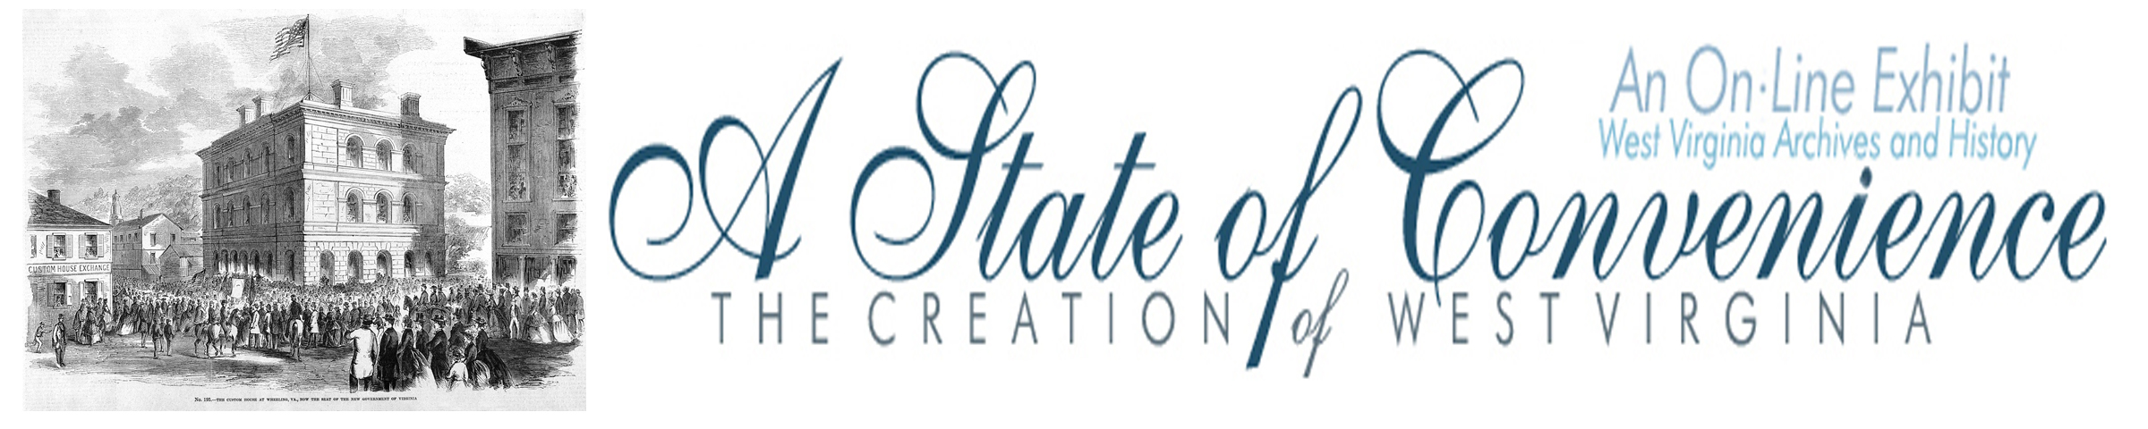

Name ______________________________________ Date _______________ Period ________

The First Session of Second Wheeling Convention

Directions: Navigate to http://www.wvculture.org/history/statehood/statehood07.html and answer the following questions.

1. When was the Second Wheeling Convention held?

2. Who was elected to serve as the president of the convention?

3. According to the president of the convention what was the purpose of the convention?

4. According to the president of the convention what were the members of the convention determined to do?

5. Where did the convention move to on June 13, 1861?

6. At the first Wheeling convention John Carlile argued for the immediate creation of a new state. What position did he support during the second convention and why did he support this position?

7. When did the Second Wheeling Convention vote in favor of the reorganization of Virginia’s government?

8. How many people in the Second Wheeling Convention voted against the ordinance to restore Virginia’s government?

9. Who was elected to fill the following offices?

Governor
Lieutenant Governor
Attorney General

Answer Key

1. When was the Second Wheeling Convention held?

June 11 – 25, 1861

2. Who was elected to serve as the president of the convention?

Arthur I. Boreman

3. According to the president of the convention what was the purpose of the convention?

“to carry out and execute, and it may be, to institute a government for ourselves”

4. According to the president of the convention what were the members of the convention determined to do?

“live under a State Government in the United States of America and under the
Constitution of the United States.”

5. Where did the convention move to on June 13, 1861?

The U.S. Custom House in Wheeling

6. At the first Wheeling convention John Carlile argued for the immediate creation of a new state. What position did he support during the second convention and why did he support this position?

At the second convention John Carlile supported the formation of a loyal government of
Virginia. He supported this position because he believed that it was the only constitutional way to create a new state.

7. When did the Second Wheeling Convention vote in favor of the reorganization of Virginia’s government?

June 19, 1861

8. How many people in the Second Wheeling Convention voted against the ordinance to restore Virginia’s government?

Zero, the vote for the reorganization was unanimous.

9. Who was elected to fill the following offices?

Governor | Francis Pierpont
Lieutenant Governor | Daniel Polsley
Attorney General | James Wheat

