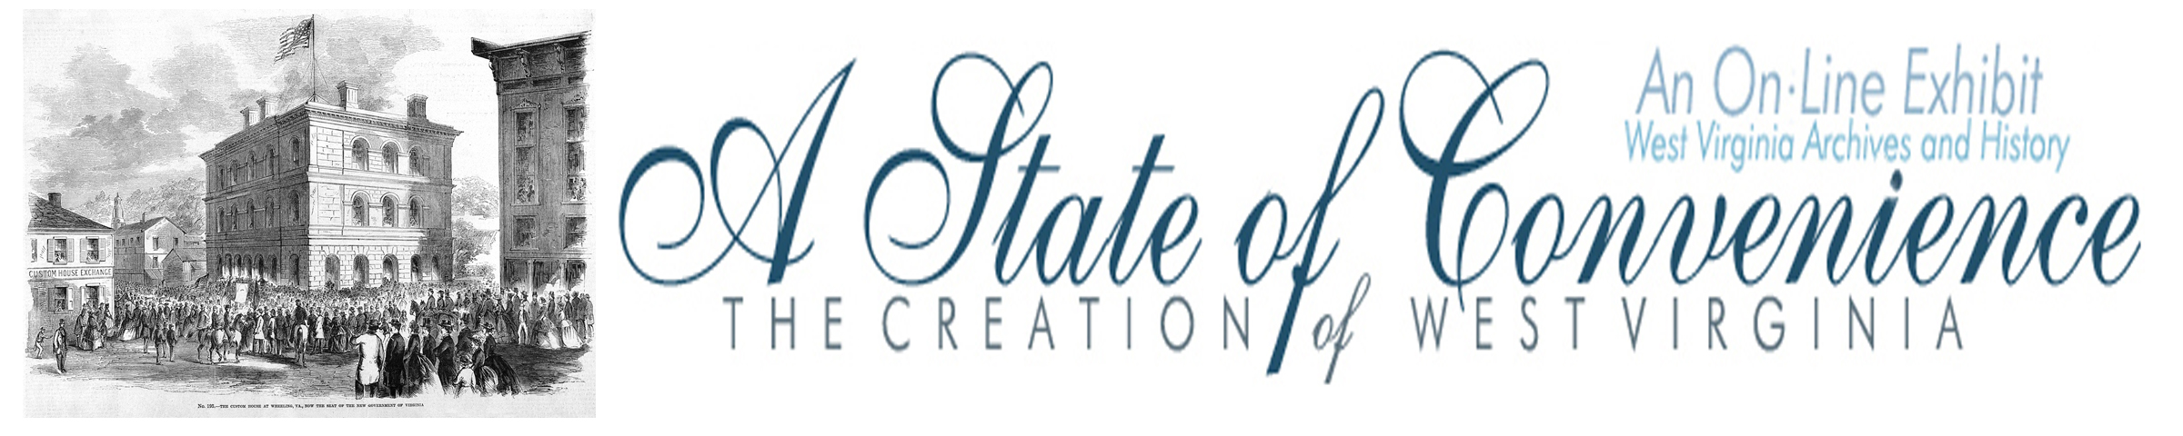

Name ______________________________________ Date _______________ Period ________

Legislature of the Reorganized Government of Virginia
Meets in Extra Session

Directions: Navigate to http://www.wvculture.org/history/statehood/statehood08.html and answer the following questions.

1. When did the Reorganized Government of Virginia meet in an extra session?

2. Who called for the extra session of the Reorganized Government of Virginia?

3. Complete the following chart.

 | Senate | House of Delegates
Number in the body

Meeting Place

Leader name

4. During his address to the legislature, Governor Pierpont:

- revealed that _______________________________________________________________

- called on the legislature to establish ______________________________________________

______________________________________________________________________________

- opposed ___________________________________________________________________

- he requested that _____________________________________________________________

5. Who was elected by the legislature to the following state offices?

Office | Person
Secretary of the Commonwealth

Auditor of Public Accounts

Treasurer

United States Senators

6. Most of the actions of the extra session of the Reorganized Legislature were related to

__________________ and ______________ matters.

7. What was the purpose of House Bill no. 21?

How did the House of Delegates vote on the measure?

How did the Senate respond to a similar measure introduced in their body?

Answer Key

1. When did the Reorganized Government of Virginia meet in an extra session?

July 1 – 26, 1861

2. Who called for the extra session of the Reorganized Government of Virginia?

Governor Francis Pierpont

3. Complete the following chart.

 | Senate | House of Delegates
Number in the body | 8 | 32
Meeting Place | Federal Courtroom  U.S. Custom House | Linsly Institute Building
Leader name | President  Lt. Governor Daniel Polsley | Speaker

4. During his address to the legislature, Governor Pierpont:

- revealed that President Lincoln pledged “full protection” to the people of western Virginia

- called on the legislature to establish an efficient system to protect the loyal people of the Commonwealth against the intrigues conspiracies and hostile acts of those who adhere to our enemies.

- opposed tax increases.

- requested that the Board of Public Works be abolished and its powers transferred to the Executive branch.

5. Who was elected by the legislature to the following state offices?

Office | Person
Secretary of the Commonwealth | Lucian Hagans
Auditor of Public Accounts | Samuel Crane
Treasurer | Campbell Tarr
United States Senators | John Carlile
United States Senators | Waitman T. Willey

6. Most of the actions of the extra session of the Reorganized Legislature was related to

__________________ and ______________ matters. (financial and military)

7. What was the purpose of House Bill no. 21?

The purpose of the bill was to create a new state.

How did the House of Delegates vote on the measure?

The House of Delegates voted against the bill.

How did the Senate respond to a similar measure introduced in their body?

The Senate tabled the measure.

