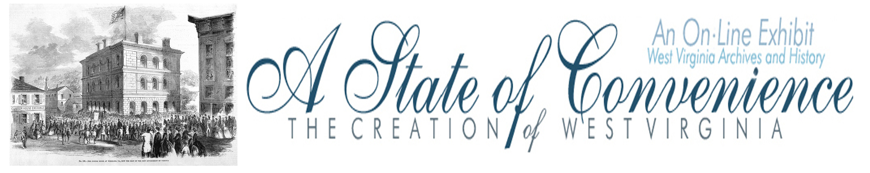

Name ______________________________________ Date _______________ Period ________

Second Session of the Second Wheeling Convention

Directions: Navigate to http://www.wvculture.org/history/statehood/statehood09.html and answer the following questions.

1. When was the Second Session of the Second Wheeling Convention held?

2. How did the Reorganized Government of Virginia respond to the Richmond Convention?

3. The convention formed a Committee on a Division of the State. What were the two major things that the committee did?

1.

2.

4. What name was chosen for the new state?

5. How many counties were included?

6. Which counties were to be added if voters in those counties approved?

7. What was the final vote total on the new state proposal?

8. When was the statewide new state proposal vote to be held?

Second Session of the Second Wheeling Convention

Answer Key

1. When was the Second Session of the Second Wheeling Convention held?

August 6 through 21, 1861

2. How did the Reorganized Government of Virginia respond to the Richmond Convention?

The Reorganized Government declared the Richmond Convention illegal, inoperative, null and void and without force or effect.

3. The convention formed a Committee on a Division of the State. What were the two major things that the committee did?

1. The committee created a dismemberment ordinance.

2. The committee proposed the creation of a new state.

4. What name was chosen for the new state?

Kanawha

5. How many counties were included?

39

6. Which counties were to be added if voters in those counties approved?

Berkeley, Greenbrier, Hampshire, Hardy, Jefferson, Morgan and Pocahontas.

7. What was the final vote total on the new state proposal?

50 for and 28 against

8. When was the statewide new state proposal vote to be held?

October 24, 1861

