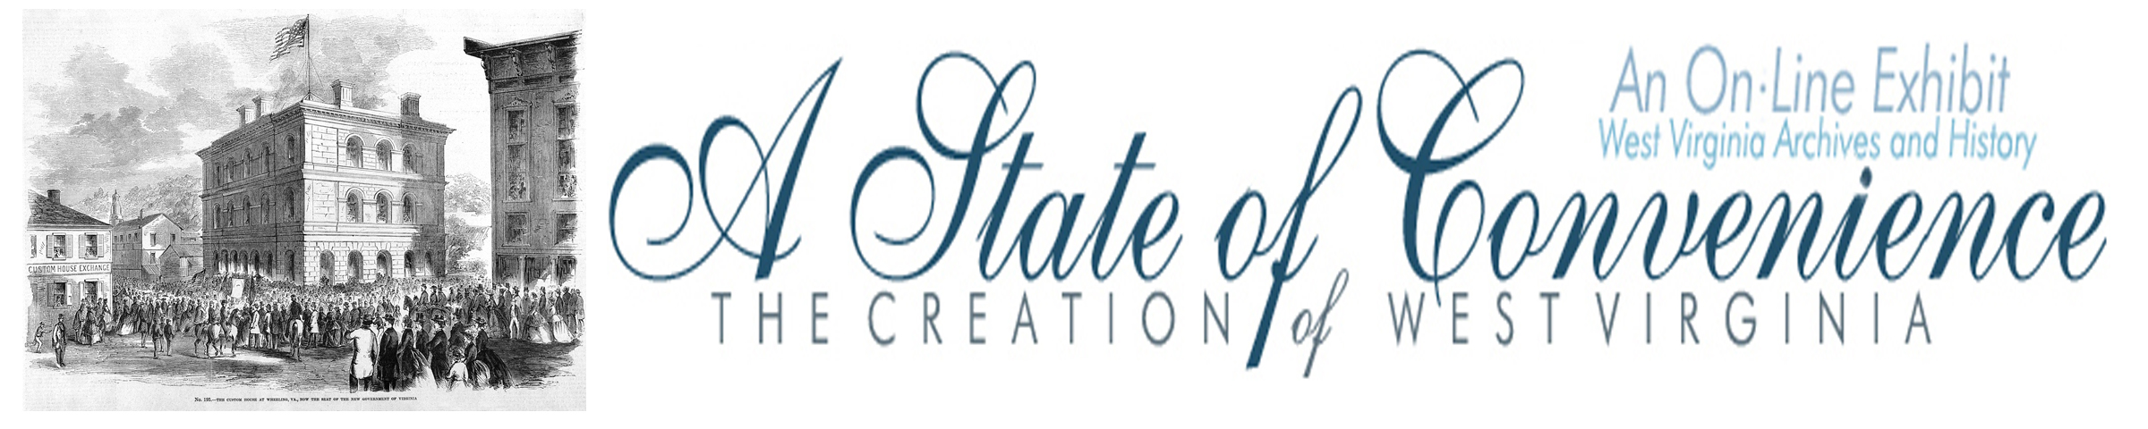

Name ______________________________________ Date _______________ Period ________

West Virginia Constitutional Convention

Directions: Navigate to http://www.wvculture.org/history/statehood/statehood11.html and answer the following questions.

1. What issues did the delegates to the West Virginia Constitutional Convention address when they met on November 26, 1861?

2. What reasons did delegates give for changing the name of the new state?

3. What other state names were proposed for the new state?
(Hint: go to www.wvculture.org/history/statehood/statename.html to see a list)

4. After the debate on the new state’s boundary, how many counties were finally considered?

original _______ , additional ______, and those awaiting voter approval _______.

5. Slavery was a very controversial subject. Following the debates, what was the final outcome?

6. What solution did Delegate Robert Hagar of Boone County suggest?

7. What solution did Delegate Gordon Battelle of Ohio County suggest?

8. On February 18, 1862, delegates at the West Virginia Constitutional Convention approved the new constitution with a ___________ vote.

9. What was the final vote total when voters approved the new constitution?

for the new constitution _____________ against the new constitution _______.

West Virginia Constitutional Convention

Answer Key

1. What issues did the delegates to the West Virginia Constitutional Convention address when then they met on November 26, 1861?

The key issues for delegates at the West Virginia Constitutional Convention were the name of the
new state, boundaries, and slavery.

2. What reasons did delegates give for changing the name of the new state?

Several things were already named Kanawha, like two rivers and a county. One delegate said that
it was hard to spell.

3. What other state names were proposed for the new state?
(Hint: go to www.wvculture.org/history/statehood/statename.html to see a list)

West Virginia, Western Virginia, Alleghany, Augusta

4. After the debate on the new state’s boundary, how many counties were finally considered?

original ___39____ , additional ___5____, and those awaiting voter approval ____7___.

5. Slavery was a very controversial subject. Following the debates, what was the final outcome?

The delegates decided that, “no slave shall be brought, or free person of color be permitted to
come into this state for permanent residence.”

6. What solution did Delegate Robert Hagar of Boone County suggest?

Hagar suggested the gradual emancipation of slaves.

7. What solution did Delegate Gordon Battelle of Ohio County suggest?

Battelle suggested that the state forbid slaves to enter the state and gradual emancipation.

8. On February 18, 1862, delegates at the West Virginia Constitutional Convention approved the new constitution with a _unanimous_vote.

9. What was the final vote total when voters approved the new constitution?

for the new constitution __18,862__ against the new constitution __514__.

