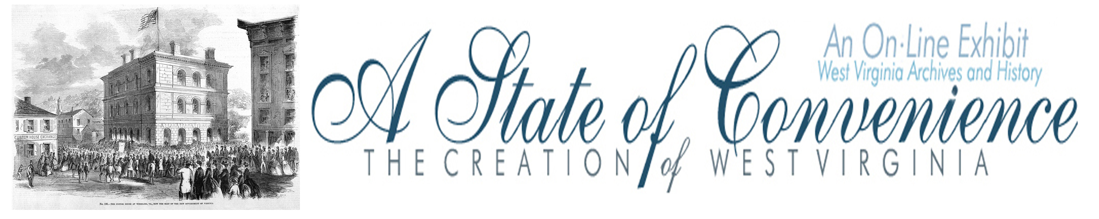

Name ______________________________________ Date _______________ Period ________

The New State of West Virginia

Directions: Navigate to http://www.wvculture.org/history/statehood/statehood16.html and answer the following questions.

1. When did voters go to the polls to elect West Virginia’s first government officials?

2. Who was the first governor of West Virginia?

3. What was the name of his political party?

4. On what day did West Virginia officially become a state?

5. Where was West Virginia’s first capital city?

The New State of West Virginia

Answer Key

1. When did voters go to the polls to elect West Virginia’s first government officials?

May 28, 1863

2. Who was the first governor of West Virginia?

Arthur I. Boreman of Wood County

3. What was the name of his political party?

Boreman was a member of the Constitutional Union party.

4. On what day did West Virginia officially become a state?

June 20, 1863

5. Where was West Virginia’s first capital city?

Wheeling

