

Name _______________________________________________ Date ________________________

West Virginia Migration Exercise
Instructions:
Use the graph below to answer the following questions.
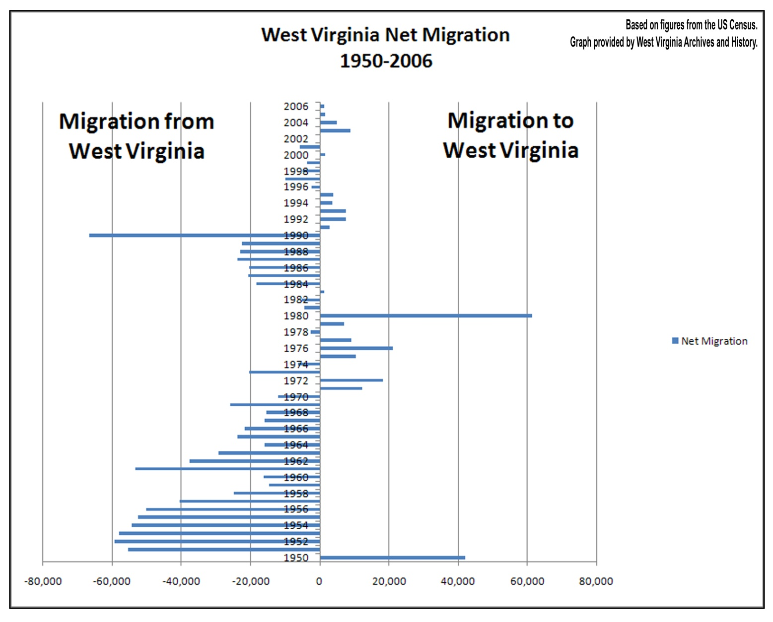
Questions
1. According to the chart in what year was migration to West Virginia the greatest?

2. In what year was migration from West Virginia the greatest?

3. What trend occurred in West Virginia between 1951 and 1970?

4. What was the trend in West Virginia between 1970 and 1984?

5. What was the trend between 1984 and 1990?

6. What is the trend for migration in the state since 1990?

7. What reasons do you think can explain migration to and from West Virginia?

