

Name _______________________________________________ Date ________________________

West Virginia Population Exercise 2
Instructions:
Use the graph below to answer the following questions.
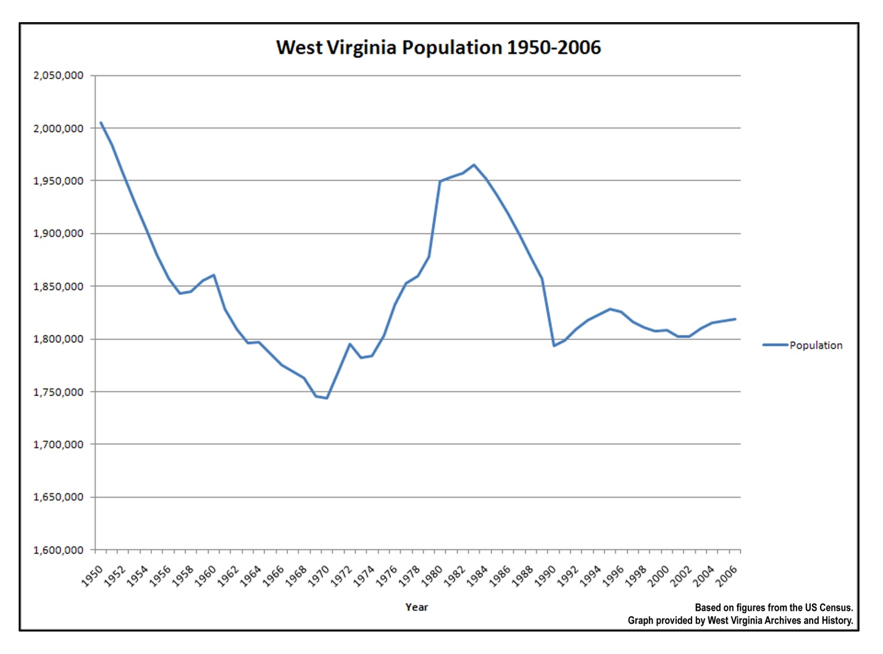
Questions

1. From the chart above when did West Virginia have its greatest population?

2. From the chart above, in which year did West Virginia’s population reach its lowest point?

3. What was the trend in West Virginia’s population between 1950 and 1970?

4. What happened to West Virginia’s population between 1983 and 1990?

5. What has happened to the population of West Virginia since 1990?

