Name _______________________________________________ Date ________________________

Virginia Secession Vote 1861

Instructions: The following political cartoon was published in Harper’s Weekly on June 15, 1861. Look at the cartoon for a full minute before answering the questions below.
Questions
1. What is the title of the cartoon?

2. Who does the man on the right represent? What is he feeling?

3. What kind of person is the man in the “yes” window?

4. What does the gun with a bayonet represent in the “no” window?

5. After looking at the picture and answering the questions above, what is the artist saying in this cartoon about Virginia secession?

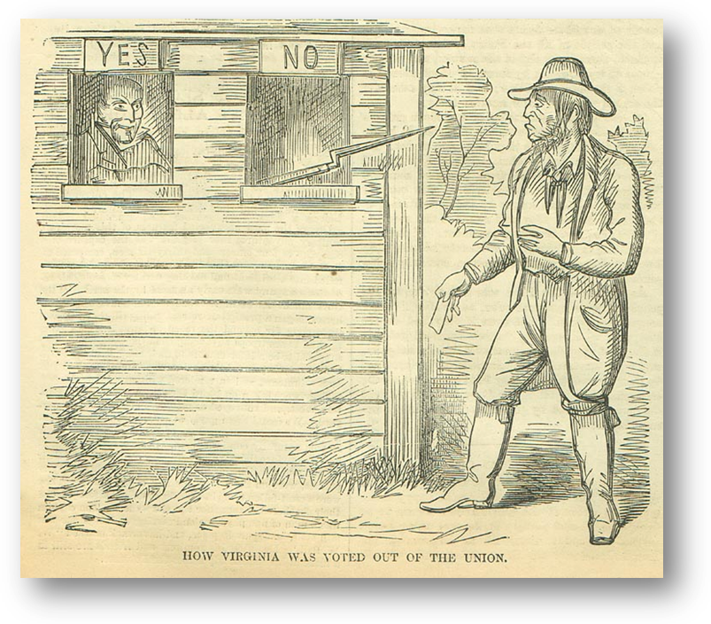
"How Virginia Was Voted Out Of The Union," Harper's Weekly, June 15, 1861.

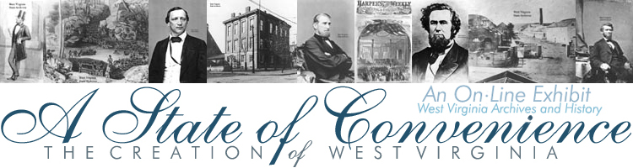
http://www.wvculture.org/history/exhibits.html

