Name _______________________________________________ Date ________________________

West Virginia Primary 1960
Instructions: The following cartoon was published during the 1960 Democratic Presidential Primary when Massachusetts Senator John F. “Jack” Kennedy ran against Minnesota Senator Hubert Humphrey. While not officially candidates in the West Virginia primary, Lyndon Johnson, Adlai Stevenson, and Stuart Symington were interested in being the Democratic candidate for president against the Republican Vice President Richard Nixon. The West Virginia Presidential Primary was important because it paved the way for Kennedy to be elected president. Look at the cartoon for a full minute before answering the questions below.
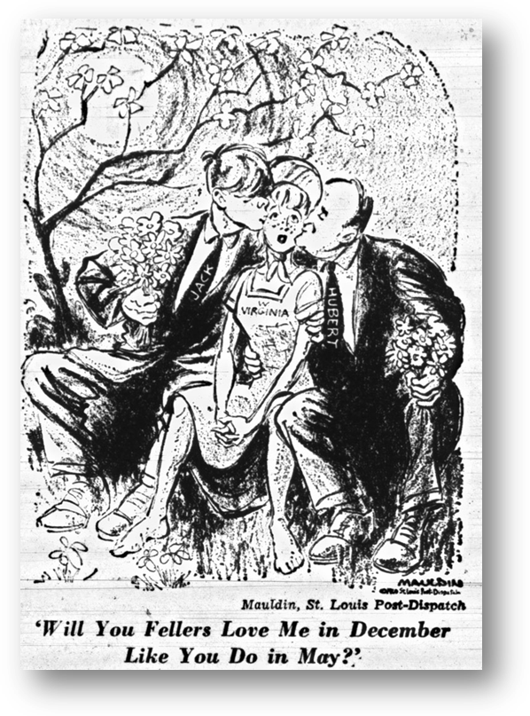
Questions

1. What is the title of the cartoon?

2. Who does the woman in the middle represent?

3. What is the purpose of the flowers and the kiss on the check?

4. What was the artist trying to say with this cartoon?
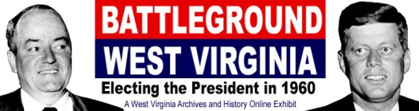
http://www.wvculture.org/history/exhibits.html

