Name _______________________________________________ Date ________________________

West Virginia Statehood

Instructions: The following map was published in The New York Herald on May 18, 1861. Look at the drawing below and answer the questions that follow.
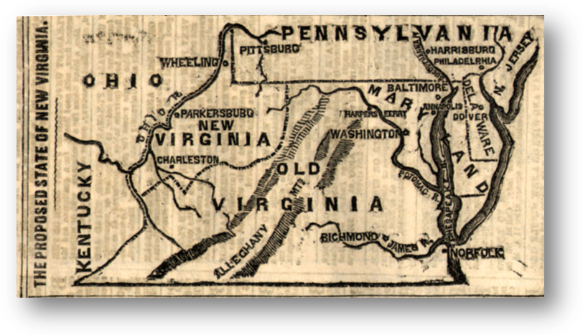
Proposed State of New Virginia, New York Herald, May 18, 1861

Questions
1. What is the title of the map?

2. What name was given to the proposed state?

3. How is the map different from the map we have today?

4. What cities appear in the proposed state?

4. What does the gun with a bayonet represent in the no window?

5. After looking at the picture and answering the questions above, whatis the artist saying in this cartoon about Virginia secession?

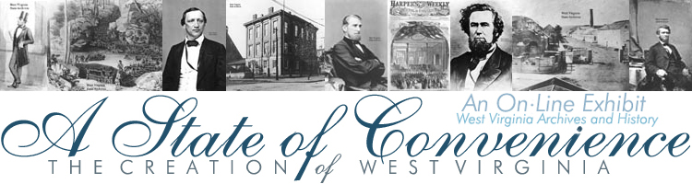
http://www.wvculture.org/history/exhibits.html

