Name _______________________________________________ Date ________________________

West Virginia Statehood

Instructions: The following drawing was published in Frank Leslie’s Illustrated Newspaper on August 10, 1861. Look at the drawing below and answer the questions that follow.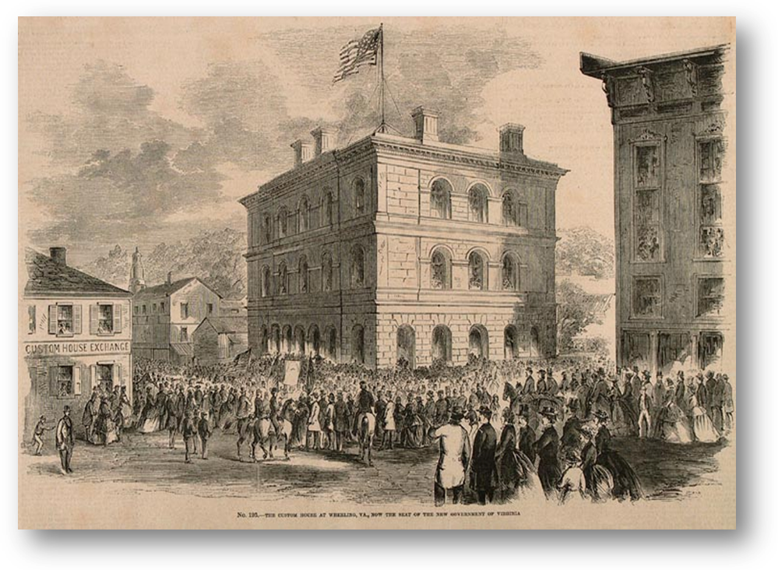

Questions
1. What is the title of the drawing?

2. Why did the capitol of Virginia move to Wheeling?

3. What do we call this building today? Why?
THE CUSTOM HOUSE AT WHEELING, VA, NOW THE SEAT OF THE NEW GOVERNMENT OF VIRGINIA.

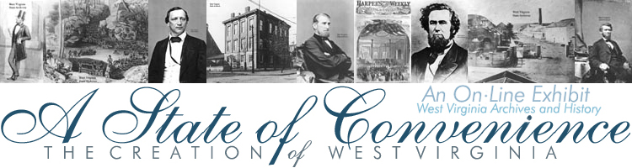
http://www.wvculture.org/history/exhibits.html

